### Reporting Agency: United Nations Development Programme Country: Republic of Armenia

### **STANDARD PROGRESS REPORT**

### No. and title: 00091029 **Integrated Support to Rural Development: Building Resilient Communities (TAVUSH)**

### Reporting period: 01 January – 31 December 2017

*Report date: 12 December 2017*

### **EXECUTIVE SUMMARY**

**2017 was the year when the Project expanded full scale in the region by providing a wide variety or assistance to various beneficiaries and** **the delivery rate was what was planned for the year**. The Project has achieved **several important results in 2017:**

1. **A total of 24 energy efficient greenhouses were installed by the end of 2017** in Aknaghbyur, Aygepar, Berkaber, Nerkin Karmir Aghbyur, Ptghavan, Sarigyugh for individual farmers.
2. **A total of 17 small agroprocessing units (wine equipment, fruit dryers)** were provided to individual farmer in seven communities in the region to individual farmers.
3. **28.4 ha of new fruit orchards were established for non-formal farmers groups in three communities.**  Seedlings of middle intensity were used to increase the volume of harvest and decrease the production times.
4. **A new greenhouse that will be producing high quality vegetable seedlings was established in Chinari for Women’s Cooperative.** This greenhouse will cover 1/3 of seedling demand of the region.
5. **Two agromachinery pools and two collection centers** were established in the region for two cluster of communities.
6. **10 ha of water saving technologies (drip irrigation)** were introduced in the region as an example of introducing best practices what will save both natural resources and expenses on irrigation water.
7. **Two water pipelines were renovated** in two communities which resulted in significant decrease in water loss.
8. **The Project helped repair two community infrastructures** with modern technologies, as prioritized in the Community Development Plans in the respective communities in 2016.
9. **With the project’s help, the planning exercise was completed in eight communities**, which were able to meet new strict requirements for producing five-year development plans. This also helped the project staff to closely engage with the communities (multiple visits, meetings), setting the stage for more effective and demand-driven implementation in 2017.
10. **Four new community-based organizations** were created with Project’s help to ensure a better management of resources.
11. **Seven school cafeteria**  have been renovated as part of partnership with WFP and SIFI as part of partnering with another Russia-funded WFP School Feeding Project in Armenia
12. **The Project is recognized as an important partner** by the Government in addressing the economic needs of borderline communities. As a result, the Project is regularly invited to meetings of Interagency Working Group on addressing the issues of borderline communities created by the Government of Armenia,

### **I. RESOURCES**

**00091029 Integrated Support to Rural Development: Building Resilient Communities**

**Total Approved Budget: USD 5,024,988.70**

Government of Russian Federation: USD 5.024,988.70

### **II. RESULTS**

## Main activities implemented and achievements as of December 2017

Foreseen activities are either completed or in the handover stage. Detailed information related to the planned and actually implemented activities and achieved results as per December 2017 are shown below.

***Development Planning Component***

**Results:**

In 2017, the Project covered eight communities in Tavush Marz, namely: Aknaghbyur, Aygehovit, Bagratashen, Lusahovit, Movses, Ptghavan, Sarigyugh, Vazashen. The planning process yielded eight community development plans which can serve as a basis for development of the mandatory five-year community development plans prepared by the LSGs. In close cooperation with LSGs and other community members at large (using integrated participatory planning methodology) the Project designed development plans and **defined the priority projects** which focus on efficient use of the human, social and physical capital assets of the community in an integrated and inclusive way. Besides the general introductory community meetings, overall 32 meeting with focus groups (local farmers, women, youth) were held in communities aimed at discussing in more details the community needs and brainstorming ways of possible solutions. The results of these discussions were summarized and included in the respective development plans of the communities. The final Community Development Plans were discussed during a Community Council meeting and were formally adopted by each Community Council with a special resolution.

**Expected Impact:** Community Development Plans will have a practical application in designing the work in the communities both by UNDP or other external donors as well as LSGs.

***Community Sustainability Activities – Agriculture and Agro-Processing Component***

**Results:**

Based on the Community Development Planning results, the Project installed **24 greenhouses** to a total of six communities in Noyemberyan and Berd Regions (Aknaghbyur, Aygepar, Berkaber, Nerkin Karmir Aghbyur, Ptghavan, Sarigyugh).

* Announcements for applying to get a greenhouse (135m2) were published in the aforementioned communities and the selection of final beneficiaries was made considering various criteria, including, but not limited the social vulnerability, enthusiasm, ability to cover part of the costs of the greenhouse, etc.
* The winner (CARD AgroService, Armenia) completed the installation works (20 greenhouses) by the mid October 2017. Four additional greenhouses were constructed (Asshin LLC, Armenia) with different parameters for four beneficiaries in Aygepar and Nerkin Karmir Aghbyur taking into consideration the overall vulnerability of the communities. All greenhouses were provided with drip irrigation installed and all necessary seedlings, fertilizers, pest control, work tools and practical and theoretical consultations.
* The Armenian Relief Society (ARS), as per signed Memorandum of Intentions signed in December 2015, partnered with UNDP to provide the drip irrigation for all the greenhouses to reduce the overall costs of the greenhouses and make them more affordable for more vulnerable groups. Initially, the ARS committed to provide drip irrigation to 12 greenhouses, however, because of successful cooperation, the total amount of ARS contribution grew to 90 drip irrigation system for greenhouses.

In response to the identified regional need, the construction of a 500m2 greenhouse in Chinari was initiated that will be **producing vegetable seedlings** for Tavush region. This greenhouse will be managed by a local **women’s cooperative.** It is expected that this greenhouse will supply up to 1/3 of the demand of vegetable seedlings in this region. The Institute of Industrial Crops of the Ministry of Agriculture of Armenia will provide mentorship to this greenhouse. Up to now the region purchased vegetable seedlings from Yerevan or Georgia, which resulted in high shipping costs and a lot of damaged seedlings as a result of transportation.

The Project provided wine production equipment to a total of nine farmers in Aygedzor, Chinari and Tavush villages. This equipment together with support with labeling and bottling will help the farmers to improve the quality of their homemade wine and enter into the market with a unified brand “Tavush Wine”. The farmers will produce limited number of bottled wine every year, with having a target of 100 bottles each for the first production year. The farmers were united into three non-formal groups in order to endure the high quality of wine is maintained and the same label is applied to all production.

Seven farmers in Aknaghbyur, Vazashen, Ditavan, Aygedzor, Bagratashen and the collection center in Voskepar received new fruit driers. This equipment will help to diversify the production cycle and will help the farmers to not only sell fresh fruit during the season, but also to enter the market with dried fruit products. This helps to avoid the seasonal price fluctuations and gives the farmers to opportunity to sell their produce later in the year at a higher price, also addressing the issue of storage or fresh produce.

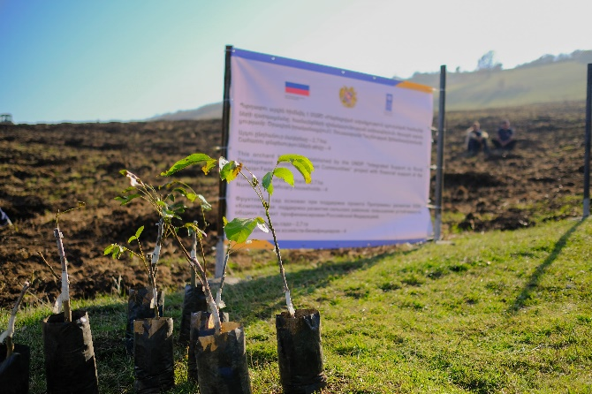A total of 28.4 ha of new fruit orchards were planted in Baghanis, Ditavan and Bagratashen villages in the region. The preference was given to intensive and semi-intensive sorts of seedlings to ensure faster investment turnover. The new walnut orchards will enter the production cycle starting from the second year of planting (instead of the 7-year period of the traditional species) which will decrease the cost of orchard maintenance during the no-harvest years. The species of orchards were selected according to the local soil and climate peculiarities as well as the economic benefits. Thus, walnuts, hazelnuts, cornelian cherries, fig, persimmon trees were planted. The farmers were self-organized into non-formal groups, and where possible adjacent land plots were selected to minimize the cultivation expenses.

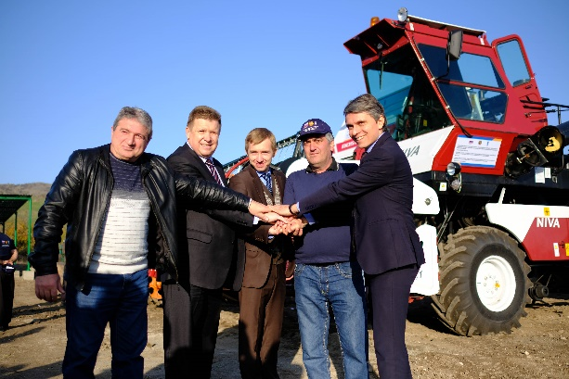Based on expressed community needs two agricultural machinery pools were established in Tavush-Chinchin and Sarigyugh-Nerkin Tsaghkavan community clusters. Each cluster received one combine harvester (Niva EFFECT) and one chain tracked tractor (ВТГ). As a result of the availability of equipment, the wheat fields in the region have nearly doubled. In particular, in Sarigyugh-Nerkin Tsaghkavan cluster the wheat fields have increased by 250% as compared from the last year.

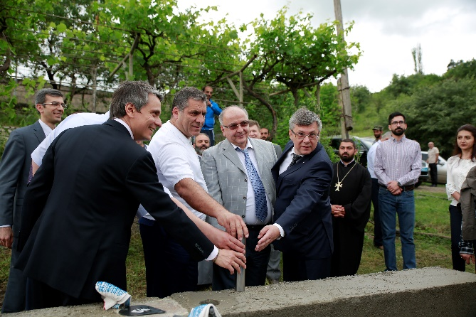Construction of two agricultural collection centers one focusing on forest fruits and agricultural produce (in Voskepar/Noyemberyan cluster) and the other on wheat and wheat processing (in Nerkin Tsaghkavan-Sarigyugh cluster) have been established in the region. The collection centers will provide service to the farmer in cold storage and processing of fruits and berries (in Voskepar) and wheat storage and milling (in Nerkin Tsaghkavan). In Sarigyugh-Nerkin Tsaghkavan cluster the community development foundation (founded by the help of the Project) is managing both the agro-machinery pool and the collection center. The Foundation has already started a “wheat bank” through which the foundation has subsidized high quality wheat seeds for their community members from their own resources and will recover the subsidies from the profits of milling complex. In addition, in the long-term run, the Foundation plans to established a farm next to the wheat mill that will feed from the wastes of the flour mill. Thus, the Foundation, with Project’s help is trying to establish a local example of circular production/economy.

In order to close the production cycle in Sarigyugh-Nerkin Tsaghkavan cluster, and based on a strong need from local entrepreneurs, the Project has assisted one young family in establishing a small bakery in the village. The bakery has the potential of becoming the main bread producer for the community, as at the moment bread is brought in from the closest town/regional center. In addition, since the bakery is right on the main road that connects Yerevan with Georgian border, the bakery has a potential to add a natural stop in tourist routes.

In order to help women entrepreneurship in the region, the Project has identified one young woman who has started a small sewing business using her household sewing machine. By providing the young entrepreneur with more professional sewing equipment, the Project supports higher income of women in the region. This will also create two additional jobs who will be involved in the sewing business in Baghanis.

The Project has also created three community development foundations and one cooperative that will manage various project-related interventions in their respective communities. These Foundations are first in their kind and introduce the concept of community-ownership and management for the social benefit. These Foundations can serve as a basis of similar management structures to be created in other parts of Armenia for managing public resources for public benefit.

**Expected Impact:**

* Improved economic conditions of the beneficiaries of greenhouses, wineries, fruit dryers, orchards;
* Increased availability of agricultural services in the region (machinery, equipment) which results in bigger volume of agricultural production;
* Employment opportunities for local population.

***Community Sustainability Activities – Energy Efficiency/Sustainable Water Management/Infrastructure Rehabilitation Component***

**Results:**

In Koti and Aygedzor a total of 7 km of LED street lights have been installed based on the identified community needs. As a result of this intervention, the communities will be able to save on street lighting component and have a safer environment in the center of the community due to improved lighting of the streets.

In order to introduce water-saving technologies in agricultural production, a total of 10 ha of drip irrigation systems have been installed in fruit orchards of Baghanis and Ditavan. These systems will save up to 50% of irrigation water, thus increasing water availability to more beneficiaries and using water resources in a more economic way. This measure is especially important considering the fact of desertification processes underway in Armenia.

3 km or irrigation water main pipeline was renovated in Nerkin Karmir Aghbyur. 1050 beneficiaries of the community will have a higher water availability and will be able to produce higher-quality products, thus, increasing their income and decreasing the water loss because of dilapidated pipelines.

The Project completed the construction of internal irrigation system in Chinari community on 54 ha of agricultural land. The new irrigation system is now used by the community and has resulted in up to 60% decrease in water loss during the irrigation season.

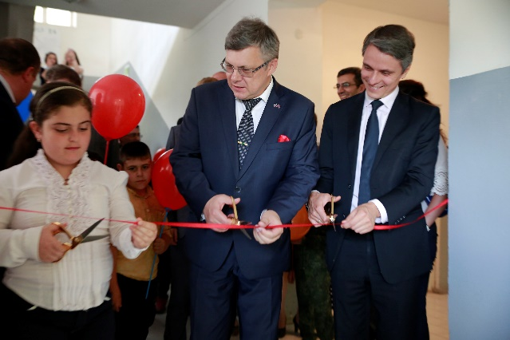As part of partnership with WFP and SIFI, the Project renovated seven school canteens in Koghb (School #1), Jujevan, Aygedzor, Berkaber, Koti, Aygepar, Nerkin Tsaghkavan to ensure the canteens used for school feeding programme meet the sanitary standards. The Project completely renovated the canteens in Koghb, Jujevan, Nerkin Tsaghkavan and Aygedzor, and provided construction materials to Koti, Aygepar and Berkaber schools to do renovations works on their own. WFP provided necessary cooking equipment in the renovated canteens.

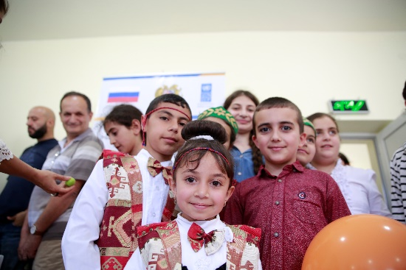As part of national “Bright Border” Initiative which aims at decreasing energy use and expenses in the borderline communities and introducing more effective technologies into everyday life, the Project purchased LED lamps for residential buildings for Voskevan, Sarigyugh and Nerkin Tsaghkavan communities. The lamps will help to significantly decrease the lighting costs of individual households, which will free up more funds from family budgets on nutrition and other necessary expenses.

**Expected Impact:**

* Improved security in Koti and Aygedzor;
* No water loss in Nerkin Karmir Aghbyur;
* Higher water savings in Baghanis and Ditavan;
* Cleaner school canteens that meet all sanitary requirements in seven schools in the region;
* Decreased lightning costs of each individual household in three communities in the region.

### **III. FINANCIAL IMPLEMENTATION**



### **IV. FUTURE WORKPLAN**

Future work plan for 2018

**The Project will expand to 10 more communities** to design Integrated Community Development Plans in those communities and implement various income generation and community rehabilitation interventions as defined by the Project Document. **More information on the expected activities in the new communities will be available by mid-2018 once the community needs and priorities are identified.**

**The project will implement the following activities, designed in 2017**:

* The Project will establish a model orchard and tree seedling production center in Ptghavan as identified by regional priorities and needs.
* The Project will continue providing greenhouses to the interested beneficiaries as well as small agro-production units.
* The Project targets at establishing another 50 ha of new orchards coupled with drip irrigation systems in the region based on the needs identified during the planning phase.
* The Project, partnering with individual donors and the community, will construct the irrigation system for Movses village which will result in increased water availability and increase of the income for the entire community.
* The Project will renovate at least three community infrastructures, including, but not limited to community irrigation water networks and community centers.